CALIFORNIA STATE UNIVERSITY
MONTEREY BAY

K-5 Science Resource Training

CAPSTONE REPORT

Submitted in partial satisfaction of requirements of the degree of

MASTER OF SCIENCE in

Instructional Science and Technology
Riffaya Salaiha Rajid Ahamed

10/30/2021

Capstone Approvals: (At least one advisor and capstone instructor should approve)

___Dr Fischer______________________ ___Nov 2, 2021________________________
Advisor Name Signature Date

___Riffaya S. Rajid Ahamed___ ___________________________ ___Nov 2, 2021_____
Capstone Instructor Name Signature Date
Table of Contents
Executive Summary/Abstract 5
Introduction/Background 6
Background on Project 6
Problem Description (Gap Analysis) 7
Target Audience and Context 8
Current Performance Levels & Desired Performance Outcomes 8
Environmental Scan 9
Solution Description 10
Goals of the Project 10
Learning Objectives 11
Proposed Solution to Fill the Gap 12
Learning Theories, Instructional Principles 13
Cognitivism 13
Component Display Theory (CDT) 13
5Ps of Instruction by Dr. Donald Fischer 14
Adult Learning Theory- Andragogy 14
Connectivism 14
Learning Strategies and Justification 15
Media Components 16
Analysis of Tasks/Content 16
Challenges 17
Methods/Procedures 18
Major Deliverables 18
Process and Steps to Complete Project 19
Resources 20
Technical Skills Required 21
Timeline 21
Milestone Checklist 21
Evaluation/Testing Report 22
Formative Evaluation 22
Summative Evaluation 24
Data Analysis 26
Conclusion 27
Current Limitations and Future Implementation 27
References 29
Appendix A: Usability Checklist 32
Appendix B: User Comments Spreadsheet 34
Appendix C: Pre and Post-Test 39
Appendix D: 3-Point Rubric 44

Executive Summary/Abstract
The Next Generation Science Standards (NGSS) provide guidelines for inquiry-based learning to motivate students to pursue careers in the field of science and technology. Although there is a plethora of resources and curricula available that align with the NGSS goal, science instructors ^{[1]} often feel that they lack preparation for science instruction. The Alameda Office of Education (ACOE) has compiled research-based and teacher-tested pedagogical and instructional strategies to support science instruction on its official website. This project is aimed at helping teachers become aware of NGSS-aligned one-stop resource compilation on the ACOE website so that teachers will be able to use these resources efficiently to enhance their classroom practice.
The online training for K-5 science instructors includes a series of screen recordings on accessing ACOE Science Resource webpages. The resources are anchored to common classroom problem scenarios to engage teachers in solving problems. In the guided practice, teachers practice accessing the ACOE website through a software simulation program. The independent practice includes a virtual environment for teachers to post their production and participate in a community of practice. All of the components of this training are housed on one website.
^{[1]} Science instructors are both classroom teachers and science specialists

Introduction/Background

Background on Project
Science instructors can find tremendous information on the web on how to teach NGSS but are often unable to fully understand its implications on classroom practice. One way to help them is by contextualizing this information using real-life classroom scenarios. Most science instructors have access to curriculum programs to teach the content but might lack sound NGSS-aligned pedagogical and instructional strategies. When equipped with these strategies, science instructors can promote student engagement and motivation regardless of the curriculum or type of content taught.
The ACOE website hosts a library of research-based pedagogical and instructional strategies compiled by master teachers and researchers. Training on navigating these resources is essential for science instructors to use the resources to inform their classroom practice. Science education in the elementary classroom is limited, and most instructors find that for various reasons they are not sufficiently supported. One way to support science education is to provide self-directed training on accessing ACOE’s library of resources. The training will increase awareness of the high-quality NGSS resources that are easily accessible and available for free. It will also illustrate the application of the resources using daily classroom scenarios so that teachers can select appropriate instructional practices that increase student engagement and motivation.

Problem Description (Gap Analysis)
The quality of science education varies across our nation, state, and even within a school. Teachers do not all have the same training or background to teach science in meaningful ways through inquiry. During the global COVID-19 pandemic, elementary students received minimal science instruction. Teachers were not prepared to teach science online and grappled with engaging students in online science education. Unfortunately, in many school districts, science education is always the most affected and is one of the first few instructions to be compromised when elementary schools are faced with unprecedented challenges.
Classroom teachers need effective training to increase awareness of sound science resources available to them so that they can continue to develop their toolbox of science instructional and pedagogical strategies. This will enable them to teach science with confidence so that they can meet the demands being made on them to engage students creatively in science education in the ever-evolving K12 school settings.
To work around the problem of finding face-to-face professional development time for all science instructors, this training is created to be accessed asynchronously and is 100% online. All training components are segmented for easy access for a refresher if teachers need to review any part of the content at a later time. Unlike face-to-face training, this online training provides teachers with continual access to a virtual posting environment that promotes collaboration amongst peers.

Target Audience and Context
The primary audience for this training is elementary science instructors. However, middle school teachers can also benefit from some of the resources. Some districts might have science specialists to teach science or facilitate labs, while other districts only have classroom teachers to teach science. If funding for employing science specialists is removed in a school district, classroom teachers have to take on the responsibility of teaching science. All elementary teachers can benefit from this training since it contextualizes resources to classroom problems. Some of the resources can be used across disciplines and can improve classroom practices across all subjects taught in elementary classrooms.

Current Performance Levels & Desired Performance Outcomes
Science teachers sometimes make the mistake of motivating students to engage in learning through attention-getting activities that are often just entertaining elements. Motivating students in the process of learning science comes from having students engaged in the process of doing science through actively engaging in the application of knowledge to real problems. To be able to do this, science teachers need science curriculum and good instructional strategies to use with the curriculum material.
To accomplish this, science teachers have to increasingly become aware of their teaching practices and identify learning problems in classrooms. Starting with a simple classroom problem and then looking for specific instructional strategies to address it is more effective in improving student motivation and learning. The desired performance outcome expected from this training is that science teachers use the ACOE library of resources to specifically select instructional and pedagogical strategies that directly address their students’ learning problems. A classroom scenario anchors the content presentation and guided practice components of the training to contextualize the learning of accessing and filtering the ACOE library of resources. At the end of the training, teachers will be able to filter resources that address their classroom problems effectively in a one-stop credible source.

Environmental Scan
In the past years, science instructors have undergone several training sessions on how to teach NGSS and exemplary practices. Trainers often present the training without providing reference to the ineffective classroom practices that exist in many science classrooms. Therefore, training often does not improve teachers' performance on the job. Training does not inform classroom practices when trainers do not address the explicit connection between training and how students' learning improves. Unfortunately, teachers often drop the knowledge acquired from training when the training does not clearly illustrate the application of the knowledge to existing common problems in classroom practices.
Most of the NGSS training sessions from the past years presented excellent classroom practices and how to teach NGSS with sample lessons and strategies. But, they did not provide a significant rationale for why existing practices are outdated and inefficient. Sometimes, the rationale provided in training did not match teachers’ rationale on why they needed to attend the training. Training that includes implications to replace existing, poor classroom practices is more likely to increase training transfer. From learning theories based on cognitive psychology, learners learn better when they are engaged in problem-solving (Merrill, 2002, p. 45). Therefore, training should require teachers to actively engage in solving existing classroom practices for it to be successful.

Solution Description

Goals of the Project
The primary goal of this training is to help teachers become aware of the excellent resources available to teachers on the ACOE website. This training begins with an introduction that clearly states the problem that the training will address and introduces the solution and the appropriate audience that the training is intended for. Then, the content presentation segment demonstrates ways to navigate the resource webpages with reflective and review-like questions to actively engage learners with the content. The real classroom problems at the beginning of the content presentation will provide a rationale for teachers to adopt these pedagogical and instructional strategies and promote critical thinking. A guided practice provides a simulation of accessing the website so that learners have hands-on practice on navigating the ACOE website.
The secondary goal of this training is to foster a community of practice where teachers can collaborate to exchange and develop knowledge of best classroom practices. This is achieved through the final learning component of the training-- independent practice-- that requires learners to create a screen recording of them accessing the ACOE website for a specific classroom problem and posting it on a forum-like web page that promotes discussions and collaborations. According to the connectivism learning theory, learners learn best when they can form connections with other people with similar learning goals (Western Governors University, 2021).

Learning Objectives
The learning goals for this training enables K-5 science instructors to do the following:
- navigate and add filters in the search bar of the ACOE resource webpage to narrow down and refine search results
- select appropriate pedagogical and instructional strategies for specific scenarios
Terminal objective:
When given a scenario of a problem in classroom practice, K-5 science instructors will be able to use the ACOE website to
  - demonstrate selecting resources by screen recording, and
  - explain their selection with a criteria checklist
Enabling objective:
When given a description of a type of resource, K-5 science instructors will be able to use the ACOE website to
  - demonstrate navigating the ACOE website by selecting the resource links, and
  - filter search results by manipulating the dropdowns on the resource webpage
Prerequisite (optional):
K-5 science instructors have a working knowledge of a screen recording application to demonstrate how to navigate the ACOE website for resources for posting in Padlet for the independent practice component.

Proposed Solution to Fill the Gap
The solution begins with creating awareness of the NGSS resource in the ACOE website. Next, learners identify that the resource can be used to address existing problems due to ineffective classroom practices. The types of content learned in this training are concepts, procedures, and principles. The level of performance required from learners is usa e and find. Every learning component in this training will fall in a cell on Dr. Merrill’s Performance/Content Matrix described in the Component Display Theory (Merrill, 2019).
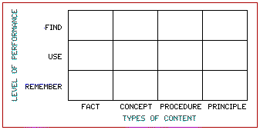
Figure 1: Performance/Content Matrix (Penn State Personal Web Server)
In the beginning, learners use (level of performance) the procedures (type of content) to navigate to the correct sections in the ACOE website. Next, learners use (level of performance) concepts (type of content) to narrow down and select specific pedagogical or instructional strategies. Lastly, at the highest level of Bloom’s taxonomy, learners use and find (level of performance) principles (type of content) to select resources as possible solutions to a specific classroom problem and write a rationale for how the strategies described in the resources address the problems.

Learning Theories, Instructional Principles
This training espouses theories and principles of Cognitivism, Component Display Theory, 5Ps of Instruction, Andragogy, and Connectivism. The following sections justify why these theories and principles are used. Additional theories and principles not mentioned, such as Merrill’s First Principles of Instruction and Reigeluth’s Elaboration Theory will be used as the training program grows into a multiple-module training packet. The potential growth of this training depends on the success of this first module when delivered to ACOE.

Cognitivism
Learning in this training requires mental processing where learners organize information and build schemas to help with retention and retrieval after the training (Cognitivism). Simple behaviors consisting of navigating the ACOE website are behaviorist elements and are also essential components of this training. However, these behaviors are enabling objectives to the terminal or the main objective of this training. Learners have to work with existing knowledge on NGSS teaching and either through assimilation or accommodation, will learn new information that they will use to enhance their classroom practice.

Component Display Theory (CDT)
The Component Display theory helps break down learning into the two main components - types of content and performance - and provides guidelines on selecting the best presentation forms to help learners achieve the learning. The CDT provides a clear map for the instructional design of this training module. Dr. Merrill’s CDT goes beyond Gagne’s Nine Events of learning and provided a granular approach to designing a comprehensive K-5 Science Resource Training module that engages learners in critical thinking.

5Ps of Instruction by Dr. Donald Fischer
Dr. Fischer’s 5Ps of Instruction are based on cognitive psychology and focuses on increasing learner motivation. The 5Ps provided a framework for creating an instructional design from the beginning to the end. This training module includes all of the 5Ps: presentation, practice, production, posting, and participation. Each one of the 5Ps includes different ways to increase intrinsic motivation in learners. The 5Ps are the most important for this training module to extend learning opportunities through the posting and participation components.

Adult Learning Theory- Andragogy
Andragogy is one of the major adult learning theories and states that adult learners need a clear rationale on why they have learned something new and how the learning will help them (DeBell, 2020). To address these elements of andragogy, this training module provides real-life scenarios in the form of classroom video recordings and teacher interviews. Andragogy also identifies that adult learners prefer self-directed learning so that they can be in charge of their learning. All components of this training are listed in a logical sequence to facilitate self-paced learning.

Connectivism
Connectivism is one of the newest learning theories and is a relevant theory for web-based learning. The Padlet used for this training provides ways for learners to reach out to others and build knowledge from there. When learners post their screen recording productions they also get to view other learners’ responses. Learners build knowledge from the diversity of responses posted and begin engaging in critical thinking processes (Western Governors University, 2021). There are potentials for the Padlet to develop into an active community of practice that will provide ways for learners to go beyond the learning goals outlined in this training.

Learning Strategies and Justification
The training adheres to the following principles of multimedia:
- The signaling principle - Screen highlights, zoom-ins, and arrows draw learners’ attention to specific portions of the screen. The signaling process is applied on-screen recordings when demonstrating how to access the resources on the ACOE website. This has helped learners focus on the important sections on the screen and reduced the extraneous information that could limit the working memory (Clark and Mayer. 2016, p. 114)
- The modality principle- Learners can process phonetic and visual information simultaneously when both visual and audio information is presented. The two cognitive channels- audio and visual- split the information processing for better understanding and retention (Clark and Mayer, 2016, p.115.) Several slides include short bullet points and images with narration that increases learner engagement.
Requiring learners to elaborate and explain the rationale for their answers in a collaborative environment provides an opportunity for learners to articulate and describe their ideas in detail. This cognitive processing helps with the retrieval and retention of knowledge and increases the probability of training transfer.

Media Components
- Introduction video presents a compelling rationale and ‘hook’ for the training, the problem that the training addresses, a clear solution, and the intended targeted audience
- Screen recordings demonstrate ways to navigate resources on the ACOE website
- Interactive video tutorials provide guided practice on accessing the ACOE resources
- Snippets of scenario videos that anchor and contextualize each screen recording and video tutorials
- A website houses all learning components and a Padlet page provides an environment for the posting productions and allow collaboration
- Additional practice and quick reference guide to help with independent practice

Analysis of Tasks/Content
The introduction on the homepage states the objective or goal training of the training in simple language. Learners know what the learning outcome is and are mentally prepared for the training. After reading the introduction on the homepage, learners navigate to a detailed introduction video. In this segment, the problem, solution, and target audience for the training are presented. Once learners gain clarity about the training, they complete a 10-question pre-test. It is important that the right answers are not revealed because they will be taking a post-test with the same questions.
A three-part learning component is next: content presentation guided practice and independent practice. Content presentation is a screen recording presentation that addresses the main learning objectives. It begins with learning outcomes and ends with a review. Several signaling elements of the multimedia principles are used to draw attention to the appropriate section of the website screen recording. Guided practice is an interactive component that learners click, type, and press keys in a simulated environment. This builds confidence and prepares learners for the final learning component, the independent practice. Independent practice provides a scenario, instructions, and submission requirements, and a link to a job aide that will help learners complete this segment. Learners post their submissions on a Padlet that allows other learners to view and comment.
The training then continues on to post-test where learners will get informed of their score. Then, they complete a quick usability survey where learners can provide feedback on the training product itself. The final component of the training is the resources section that houses the job aide to navigate through the ACOE science resource webpage and the website link to the ACOE Science Resource page. To clearly mark the end of the training, learners click on the “Complete” button at the end to navigate away from the training website.

Challenges
The drawbacks for this project are reduced time limit to complete the project due to pregnancy and a lack of engagement with other professionals for reflection and collaboration. I worked with a separate calendar of due dates to help me complete my training on time and worked closely with my mentor for feedback and suggestions.
I created an interactive video tutorial for content presentation using Camtasia. The learning curve with Camtasia was steep since I added quiz questions. Camtasia only provides a limited bandwidth of uploads in the free account. This limits the number of revised publishing I can make. The guided practice was created using Adobe Captivate and was challenging to work with since the SCROM and quiz settings were preventing learners from progressing. After several iterations, the guided practice component worked well. I removed the quiz summary report to enable smoother transitions from slide to slide on the guided practice. This is not a major issue since each quiz item already included immediate feedback to learners.
All of the training components were first housed in a Google Hyperdoc, but after a course on interactive web-based multimedia, I housed all the components on a website so that learners did not have to toggle between browser tabs and windows. I used HTML and CSS libraries to use as templates for my website which came with its own set of learning limitations. Some of the files were too large and some iframe components were too small. After researching and studying webpage design through freely available resources such as W3 Schools, I finally created a product that optimizes the user experience.

Methods/Procedures

Major Deliverables
After sifting through the resources on the ACOE website to select a few versatile ones to include in the training, several screen recordings as instances on how to access the resources were created. Just for this part alone, the backward design approach was used as introductory scenario videos were only inserted after selecting the resources. This backward design model helped me create a much more efficient training. There are several hundreds of resources available under pedagogical and instructional strategies on the ACOE website. In this training, I only provide a few instances of navigating these resources.
The content presentation and guided practice components are presented in the same order of events-- scenario, accessing ACOE website, using filters, followed by revisiting scenario. The major difference between the two is that the content presentation just provides a video presentation, while the guided practice component provides a simulation of browsing the website.
The website link that houses all my learning components, introductions, tests, and surveys is my final product. The website is hosted using host gator, a web hosting service. By purchasing a domain main and hosting my website using File Transfer Protocol (FTP), the website went live within a few seconds. The major advantage is that there is no space limitation on how many files can be uploaded. The main disadvantage is that school districts will have to enable the website under ‘allow list’ as the website source is from an unknown server and has been reported to go under ‘deny list’ due to security protections.

Process and Steps to Complete Project
This project was completed successfully in mid-October with about five rounds of testing and re-iterations. Since this project is based on realistic and common problems faced by science instructors, it was highly motivating for me to work on this real-world task. The solution presented in this training is simple, yet effective, and only involves training on accessing district-approved resources. All content required is already available and there is no need to create new content for this training. The training is simply a planned presentation of what is already available, preceded by concrete classroom problem scenarios. The resources presented in this training are effective instructional and pedagogical strategies and are proven to be helpful to classroom teachers regardless of the curriculum.
The following were the micro-deliverables of the training module:
- Gathering resources on the ACOE website
- Introduction video with a ‘hook’ and concise overview and rationale for the training
- Screen recording a demonstration on navigating ACOE resources
- Interactive screen recordings on Camtasia for guided practice
- Multiple-choice question pre and post-test and a usability checklist using Google Forms
- Website to map out the learning module in a logical sequence

Resources
Type of Resource | Details
time | 8 full weeks
money | there is no need for any budget allocation for this project since all resources were available for free
hardware | computer
software | Google suite of products, Camtasia software, Captivate, internet browsers for research and content
training | Camtasia and Adobe Captivate for screen recordings and webpage building tools such as Adobe Dreamweaver and GitHub to push the website onto a server
external expertise | ACOE representative- detailed training was provided during the summer.

Technical Skills Required
Camtasia training is available in short, three to ten-minute video tutorials on the Tech Smith website. They are free of charge and are easy to understand. Watching these videos did not take a significant amount of time towards completing his project. However, planning and creating a storyboard did require several reiterations. Adobe Captivate and Dreamweaver took over 50 hours of training and production.

Timeline

Milestone Checklist
Deliverables | Description | Timeline | Status
Capstone Storyboard | Course outline with media placeholders and navigation | 9/21/21 | Completed
Resource Gathering | Filtering from ACOE website to select for screen recording and selecting scenarios from YouTube videos of science classroom recordings | 9/15/21 | Completed
Video Editing | Compiling and editing videos to illustrate possible scenarios | 9/15/21 | Completed
Project Component Part 1 | Content presentation screen recordings and guided practice on Camtasia and Captivate | 9/21/21 | Completed
Project Component 2 | Independent practice, additional practice, a quick reference, website | 10/10/21 | Completed
Project Checkpoint | Share project progress with advisor and post on Canvas | 10/19/21 | Completed
Complete Capstone Project | Complete all components of the capstone project | 10/28/21 | Completed
Capstone Project Presentation | Pre-recorded video for Capstone Presentation | 11/15/21 | In progress

Evaluation/Testing Report

Formative Evaluation
I tested this project with colleagues and family members regularly to improve the usability of this training using a usability checklist (See Appendix A). I also consistently worked with my mentor for feedback. I tested each component regularly and modified instructional materials and design several times a day.
Beta Testing- Learners recruited to participate in this module were interviewed to assess their prior knowledge and in using free resources on the ACOE website and their ability to use a screen recording application. All five learners did not have an in-depth knowledge of the science resource website. One of them was aware of the resource website but did not know how to fully utilize it for classroom needs.
A usability test was conducted with five learners before finalizing the training module. The results helped improve navigation, instruction delivery, and other functionalities of the training module. By observing participants while they are going through the entire module, even small behaviors that indicate difficulty in using the training module were easily identified and rectified. All observations and feedback were documented on a spreadsheet (See Appendix B)
Recommendations
- Add a section for users to post a list of recurring class problems. This way teachers can provide solutions to one another and engage in extended discussions beyond the three scenarios presented. This is to foster the community of practice and increase learner engagement in real classroom problems.
- Allow users to access “Quick Reference” on the independent practice component so that learners are not stuck while completing the independent practice. Although the content presentation and guided practice components are easy to access for review, it is best to have a printable or one-page instruction on how to access the ACOE website. This is easier than viewing the video recordings from the beginning.
- Rename “Resources” to what that section actually houses-- “Website & How-To.” This simple idea will increase learners’ clicking on this tab since the contents of the tab is specific. Some users might not click on the “Resource” tab thinking it’s resources that offer extension activities or resources used to create the contents for the website. By being clear about what the resource contents are and using that as the name, users are more likely to click on the tab to access and use the contents posted on that tab.
- Make all video iframes to enable all components to be viewed at all times, such as the ‘next’ and ‘previous’ buttons. The in-built pages were first small, but after making them full screen, the top panel disappeared and hid the buttons that allowed users to progress. Enabling the view of all components of the webpage is important for learners to toggle across the learning components as needed.
- Add an introductory onboarding mini-training, “How to Navigate the Website” in the beginning. This simple, yet another clever idea from a user, will reduce user frustrations when the webpage fits their monitor screens differently and makes content somewhat distorted. An onboarding training that shows how to navigate the screen is useful for any new application or website.

Summative Evaluation
Knowledge check questions are embedded in the guided practice to check learners' understanding of the skills taught at the training. Immediate feedback is provided to all knowledge check questions. The goal of the knowledge checks is to help learners become aware of their learning and to gently guide them in the right directions. The scores are not recorded to evaluate the success of the training.
An additional knowledge test is a two-part posting assignment in the Independent Practice component. Learners post a screen recording and a rationale write-up on Padlet for a specific problem scenario. This posting component of the training is graded using a 3-point rubric (see Appendix D) and is an authentic evaluation of learners’ ability to use the skills learned in the training. Learners have multiple opportunities to re-record their screen recording before they post their final recording on Padlet which could reduce test anxiety and improve the quality of postings. The two-part assignment allows learners to be creative and thoughtful about their postings and provides a much deeper evaluation of learners’ understanding.
After several users provided feedback, an option to post without a screen recording was added to enable learners to participate without having to create a screen recording. This enables learners without the know-how on screen recording tools to still be able to post the resources that they sifted through in the ACOE webpage for a specific classroom problem and collaborate with other peers.
A level 1 evaluation was done by interviewing learners after completing the training. All learners agreed that the learning components were designed to help learners retain information and apply it when they needed to find science resources. One of the middle school teachers was motivated to create a repository of all the resources that she selected from the ACOE website and other sources.
A level 2 evaluation was completed to determine the effectiveness of this training using the data from the ten-question pre and post-tests. Both the pre and post-tests are identical and a Paired Sample for Mean t-Test was run to either accept or reject the null hypothesis that the training would have no effect on the test scores and that there would be no statistical significance between pre and post-test scores.

Data Analysis
The null hypothesis is that this training will have no effect on learning whereby the mean of pre-test scores will be equivalent to the mean of the post-test scores. The alternative hypothesis is that the training will positively affect learning whereby the mean of the post-test scores will be higher than the mean of the pre-test scores. The conventional alpha level of 5% is used for these hypotheses.
Five learners’ pre and post-test scores were collected for inferential statistical analysis. The summary of the pre and post-test scores is recorded below.
Pre-test Score | 5 | 4 | 0 | 3 | 5
Post-test Score | 9 | 10 | 10 | 10 | 9

All five students scored 90% or above in the post-test. To determine the statistical significance, the one-tail value was used since the hypothesis is directional. The t Stat absolute value of 5.56 is higher than the t critical value one-tail value of 2.13. The pre-test (variable 1) has a mean of 3.4 and a standard deviation of 2.07 and the post-test (variable 2) has a mean of 9.6 and a standard deviation of 0.55. The pooled standard deviation is 1.52 and the effect size is 4.1, [t(4)= 5.56, p<0.05 and d= 4.1]. This shows that the results are practically significant.
Since the p-value of 0.0025 is significantly smaller than the conventional alpha value of 0.05, the null hypothesis that the intervention will result in no significant difference in the pre- and posttest means is rejected and the alternative hypothesis that the training positively affected learning is supported as evidenced by the improved post-test scores.
 | Variable 1 | Variable 2
Mean | 3.4 | 9.6
Variance | 4.3 | 0.3
Observations | 5 | 5
Pearson Correlation | -0.704360725
Hypothesized Mean Difference | 0
df | 4
t Stat | -5.567764363
P(T<=t) one-tail | 0.00254877
t Critical one-tail | 2.131846786
P(T<=t) two-tail | 0.005097541
t Critical two-tail | 2.776445105

Conclusion
The statistical analysis supports the alternative hypothesis that the training has improved test scores and that learners have improved knowledge on accessing the ACOE website of science resources. The usability survey data shows that the training is user-friendly and that the instructional design adheres to multimedia principles. Learners suggested that an on-boarding training to provide an overview of navigation functions of the website would be useful. All learners mentioned that the training achieves the learning objectives. Four out of the five learners also reviewed the first draft of this training. They mentioned that the website hosting all the learning components looks professional and is also easy to navigate.

Current Limitations and Future Implementation
Areas to work on include making these learning components accessible without having to go through the security firewall so that it becomes accessible for teachers when accessing from their district network. The first draft created with Google Hyperdoc would address this issue, but that would compromise the user experience. The ease and accessibility in navigating between learning components have been a major advantage for the learners while the Google Hyperdoc adds extraneous cognitive overload to learners as they have to remember their progress in the training and navigate to the right section on their own toggling between tabs or web browsers.
The first step in implementing the training is to work with the school district’s IT department to add the training website to the ‘allow list’. This may take time and district officials may not give priority to this. Alternatively, teachers can complete the training through their home network. After ACOE science specialists review the training product and concur that this training product will benefit teachers, districts will perhaps be more agreeable to allowing the training website to be accessed through their firewall security.
Since the training is not dependent on the curriculum that a school district has adopted, the training can be implemented state-wide. As more teachers complete the training, a blog-like feature might be added to the website so teachers can continue to collaborate in the Independent Practice segment. Overall, this training is practical for immediate use and can be used for years to come.

References
Clark, R. C., & Mayer, R. E. (2016). E-learning and the science of instruction (Ruth Colvin Clark & R. E. Mayer, Eds.; 4th ed.). John Wiley & Sons.
Cognitivism. OLCreate: General Teaching METHODS: COGNITIVISM. (n.d.). https://www.open.edu/openlearncreate/mod/page/view.php?id=147079.
DeBell, A. (2020, July 24). How to USE Mayer's 12 principles of multimedia Learning [EXAMPLES INCLUDED]. Water Bear Learning. https://waterbearlearning.com/mayers-principles-multimedia-learning/
Fischer, D.C. (2021). General Presentation, revised Feb 6, 2021; presented January 22, 2021. Access with author permission (dfischer@csumb.edu, dfischer@swcp.com); https://docs.google.com/presentation/d/1HALaKAehTq4kW7BFknUKHjWzd8dQIbrRVuzYVnJkg1Q/edit?usp=sharing
Merrill, M. D. (2002). First Principles of Instruction. Educational Technology Research and Development, 50(3), 43–59. https://doi.org/10.1007/BF02505024
Merrill, M. D. (2019). The Descriptive Component Display Theory. https://mdavidmerrill.files.wordpress.com/2019/04/cdt_chapter7-1.pdf
Pen State Personal Web Server. (n.d) Merrill’s Component Display Theory. http://www.personal.psu.edu/wxh139/CDT.htm
Teaching Strategies. Alameda Office of Education: Elementary Science Partnership. (n.d.) https://esp.acoe.org/instructional-strategies-and-resources/searchable-instructional-strategies-and-resources
Western Governors University. (2020, April 7). Adult learning theory. Western Governors University. https://www.wgu.edu/blog/adult-learning-theories-principles2004.html
Western Governors University. (2021, May 27). Connectivism learning theory. Western Governors University. https://www.wgu.edu/blog/connectivism-learning-theory2105.html

Appendix A: Usability Checklist
Link to the usability checklist on Google Form
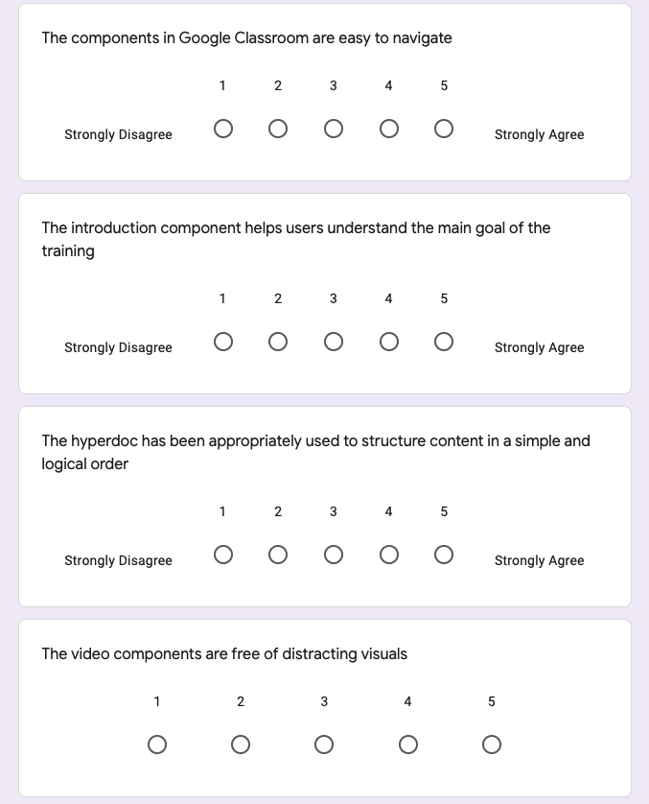
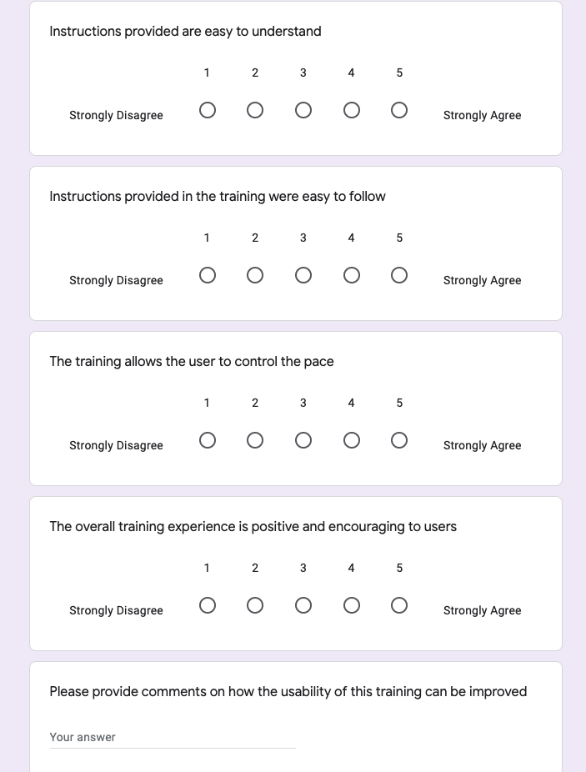

Appendix B: User Comments Spreadsheet
Link to the user comments spreadsheet

User Comments / Date | Solution | Status | Published (Y/N)
Dr. Fischer, 10/28/21 | Change Table of Content to Table of Contents | in progress
 | Check 'guided practice' loading | in progress
Dr. Fischer, 10/25/21
Add instructions to tell people to click on the 'next' button- Onboarding training at the beginning of the training | Create an '"On-boarding" training and a help button that links to 'onboarding training. | alternative solution: keep all next and previous buttons on screen without requiring scrolling so it is intuitive for users to click next when done | Applied alternative sol. Not published yet
Tell people to scroll a little on the video pages | Add instructions on the video iframe pages to let learners know that they have to scroll down a little bit | not needed- an alternative solution to keep all windows dimensions to fit screen rather than requiring scrolling | Y
Lots of confusion from the "next" button at the end of the 'post test' page | change the link from resource.html to content.html | done | Y
Captivate took back to the beginning rather than just rewind to the previous part of the video | remove the 'back' button and add 'rewind' button | done | Y
guided practice includes 'pre-test' rather than 'post-test on the first and last part of the scenario component of guided practice | edit Camtasia file, download and then upload to captivate and republish | done | Y
Dr Fischer, 9/29/21
Need instructions to return to the LMS page after viewing Introduction. | House the training components on an HTML page with buttons | editing Camtasia | N
The pre-test looks good. | √
Content Presentation. The first slide breaks up, Why? | remove transitions | done | Y
In the content, the question on filters. Why would I remember the filters? Then comes a question that asks me to do that, so I need a button to go back and pick the right filter. But then, how do I remember the quiz question? Why would I want to do either? | Change the question to a reflection-like question: One of the filters on the webpage is learning goals. Which one of the following would be considered as learning goals? | done | Y
It would seem that while the view of the filters is up, the question should appear and have the person select the correct filter. | Change the question to a reflection-like question: One of the filters on the webpage is learning goals. Which one of the following would be considered as learning goals? | done | Y
On building understanding, I did not get what the solution was. And what is "S"? | add details for what S is | done | Y
A quiz question: | - |  | Y
A same classroom problem can be addressed with different types of resources. T or F. | - | done | Y
Instead of "A same classroom problem" I recommend "Similar classroom problems ..." | fix the question | done | Y
On the guided practice, you say "Let's use the scientific method ... " Then there is no button to move on. | add button- End button already in place- check functionality |  | Y
If it is not clearly said, have them bring up the page and do what you say to do in the video. | Add this to the presentation | done | Y
"Let's see how this is implemented in the classroom." No content. The teacher is shown but the clip ends. Then comes the slide referring back to the problem where it says I can't imagine teaching without S. What is "S"? | changed narration to: "Let's revisit the scenario.." and added details to what S stands for. | done | Y
Guided Practice: No button getting back to LMS | House all components in an HTML page | DONE | Y
On the Quiz, no feedback on the T or F, got feedback on question 2, no feedback after submitting on the matching. | check SCROM and feedback | done | Y
Independent Practice and Posting is interesting. The fonts on the questions and on the Independent Practice and Posting are very small. Is there a way to increase the size? The instructions are pretty clear. | check with other users
Again, great work. What a project! | thank you | -
Dr. Fischer, 9/29/21
Eventually, if you type up the comments, I would like to see them. It keeps me in touch with reality. | done
On scoring the pretest, I would want to know the score and be told that I will know what the right answers are by the end of the instruction. You could then, somehow and somewhere, reiterate the benefits of the instruction. | send scores, do not reveal correct answers. Add this in the next learning component. | this will be added to the website where all the components will be housed---done | Y
On the filters questions, if you told them to have their own page from the site up, so they could see the filters page, they would have a good chance to answer the questions. | changed the filters question | done | Y
On the "S" issue, spell it out. If it bothers you because it is a direct quote, put the additional letters are in brackets. | Yes, add that in brackets | done | Y
I don't know if I was looking at a Padlet or the Google slides. I am talking about the banners at the top of the slides with the questions. If the answer options were on Padlet, those were OK. | check with other users as well |  | Y
That slide that broke up broke into horizontal bars. It is at the end of the first segment on Content Presentation Part 1. | check and fix | done | Y
Kumaran, 9/28/21
Add another clickable area for instructional strategy resource | allow another clickable button | done | Y
Change audio to select ‘elementary … in the browser” | priority level 2 | - | Y
Add arrows to help point where to click | check with other users |  | Y
Repeat audio button | add a replay button to play slide again | done | Y
Add blocking area for bookmark and other distractions on the browser | priority level 3 | done | Y
Add frames around the window to separate from TOC | priority level 1 | done | Y
Add arrows | check with other users | done | Y
Keep textbox incorrect box longer on the slide | priority level 1 | done | Y
Check quiz feedback-- inconsistent | priority level 1 | done | Y
Hotspot submit button not working | priority level 1 | removed and replaced elsewhere | Y
Arya, 9/27/21
An incorrect message is not accurate enough | done | Published | Y
Change ‘groupings’ to whole area rather than just the small arrow | done | Published | Y
Fix all ‘incorrect’ messages for clarity | done | Published | Y
Add voice over at 20 strategies | done | Published | Y
Quick Review- weird font on the title | done | Published | Y
Make all continue and submit buttons consistent with the positioning | done | Published | Y
Add ‘next’ or ‘skip’ button for hotspot | done | Published | Y
Riffaya, 9/25/21
Guided Practice component: |  | Published
re-upload guided practice to a better quality of the mp4 file. Change the frames/min to see if quality improves | done | Published | Y
Resource #1 - check the audio, it’s not playing | fixed | Published | Y
Change ‘flicker’ animation to something else- not pleasing for view | changed | Published | Y
Quiz #1 - check time | Check SCROM |  | Y
Quiz #2 - spell check | Check SCROM |  | Y
Check Matching submit button- it’s not working | Check SCROM |  | Y
Hotspot slides- change instructions for clarity, add transition | done | Published | Y
Credits slide too long | shorten | Published | Y

Appendix C: Pre and Post-Test
Link to the pre and post-test on Google Form
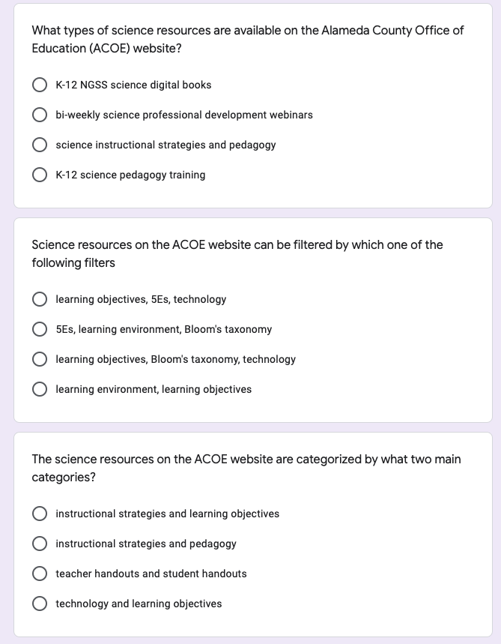
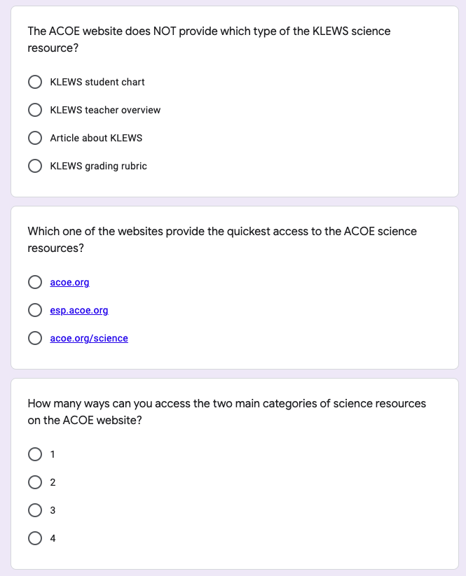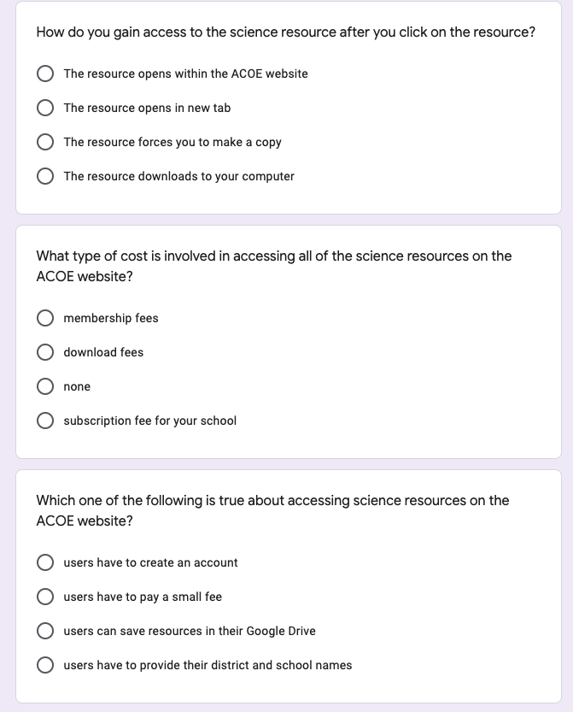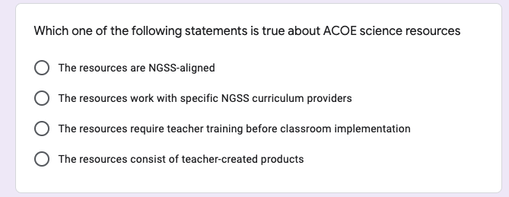

Appendix D: 3-Point Rubric
The following 3-Point rubric will be used to grade screen recording postings.
 | 1 | 2 | 3
Screen recording | The screen recording posted does not clearly show the resources that the learner selects with five or more *re-directions or mistakes from the beginning to the end. The overall recording is somewhat unclear. | The screen recording posted shows the resources that the learner selects with fewer than 4 *re-directions or mistakes from the beginning to the end. The overall recording is somewhat clear. | The screen recording posted clearly shows the resources that the learner selects with fewer than 3 *re-directions or mistakes from the beginning to the end. The overall recording is clear.
Navigating ACOE resources efficiently | The screen recording demonstrates the learner's ability to access one of the two main science resources on the ACOE website.  The learner does not use the filters to select resources. | The screen recording demonstrates the learner's ability to access one of the two main science resources on the ACOE website but with several errors.  The learner uses filters to select one or two resources. | The screen recording demonstrates the learner's ability to access both of the two main science resources on the ACOE website without any errors.  The learner uses filters to select at least three resources.
Rationale write-up | The written rationale does not include sufficient explanations for how the resource can be used in the classroom with no reference made to the problem scenario. | The written rationale includes explanations for how the resource can be used in the classroom, but without sufficiently referencing the problem scenario. | The written rationale includes sufficient explanations for why or how the resource will address the problem scenario.
*re-directions include going to destinations that are irrelevant within the website and having to close any irrelevant tabs and/or having to click on the back arrow to be redirected

